**Heart Attack Data**

This data is taken from kaggle.com. There are many of information in this dataset about who has a heart attack. There is the age and gender of the patient, resting blood pressure, fasting blood sugar, previous peak, angina type (yes or no), slope, number of major vessels, stress level test (0 – 3), chest pain type(0-Tipikal,1-Atipikal,2Non-Anginal,4-Asymptotyic), cholesterol, resting electrocardiographic result, max heart rate and output (end of the patient healthy or unhealthy). I visualisation and compare some variables in R studio.

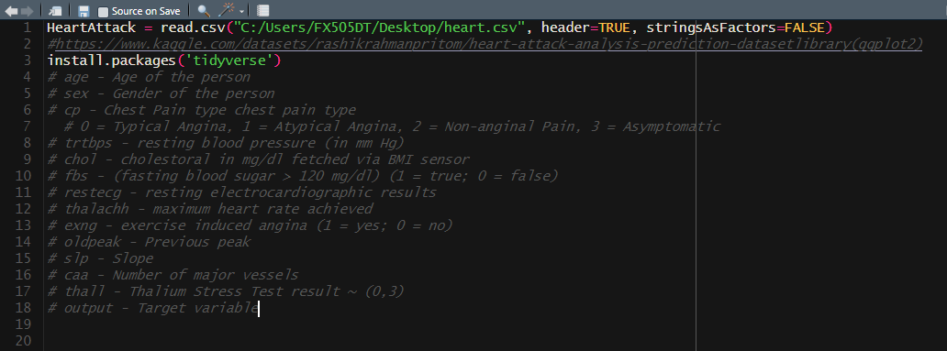

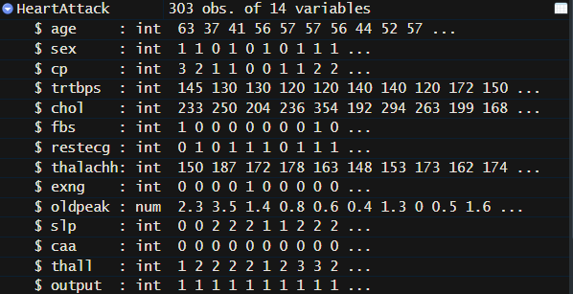

1. In the first graph, I have shown the distribution of heart attack patients by gender. It can be seen from the graph that the number of female patients is approximately 2 times more than the number of male patients. 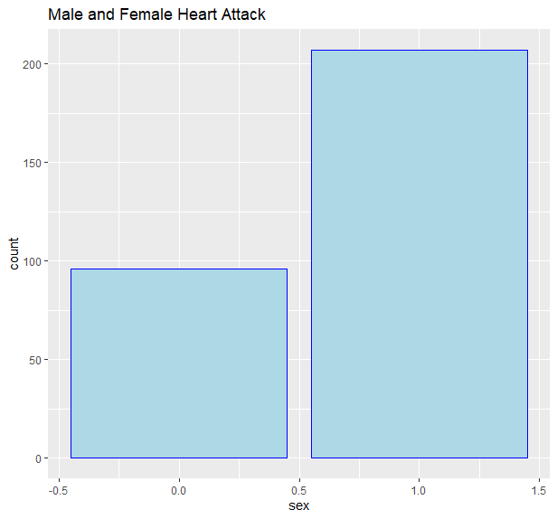
2. In the second graph, I have shown the number of patients age with heart attack. According to this chart, more heart attacks occur at the age of 55-60. In our data, the youngest person who had a heart attack was 30 years old, and the eldest person who had a heart attack was after the age of 80. According to this analysis, people in their 50s and 60s should pay more attention to their food and health. 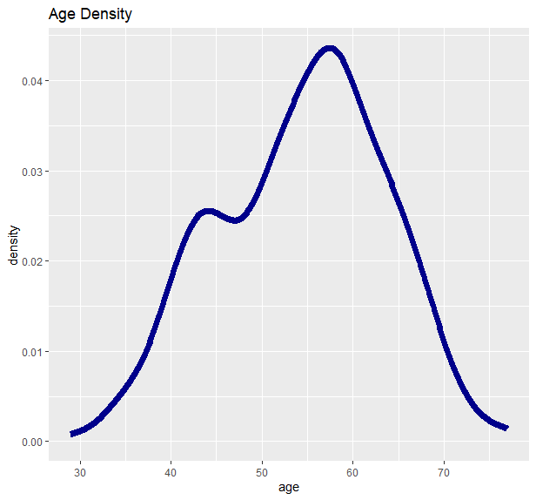
3. As we know, there are 4 types of chest pain. In this graph, I have shown the significance of chest pain type by age and gender with a bar blot. Shades of blue indicate the type of chest pain. 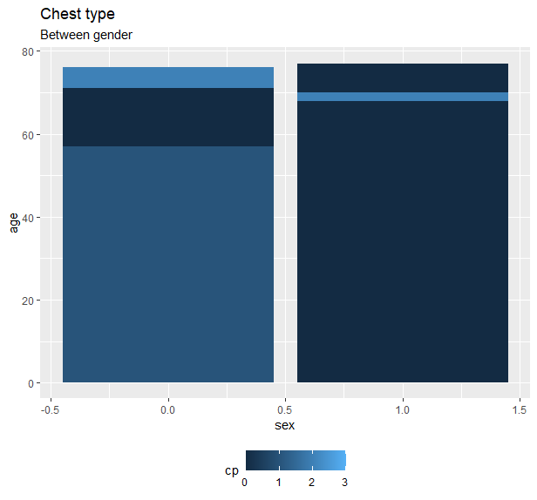
4. In this graph, I have shown the authenticity of resting blood pressure and resting electrocardiography results according to gender. Red color represents men and blue color represents women. 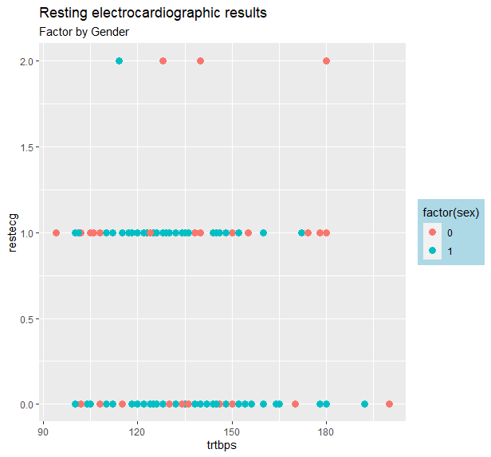
5. Max heart rate and old peak dependency. Dark blue shows those whose output result is 1, while light blue shows those whose output result is 0. From the analysis of this graph, it can be concluded that those with positive output results have higher previous peak and lower max heart rate. If the output result is 0, it is the same. This means that the old peak shows more and the max heart rate decreases automatically, since the current peak of the sick patients is less than the previous one. 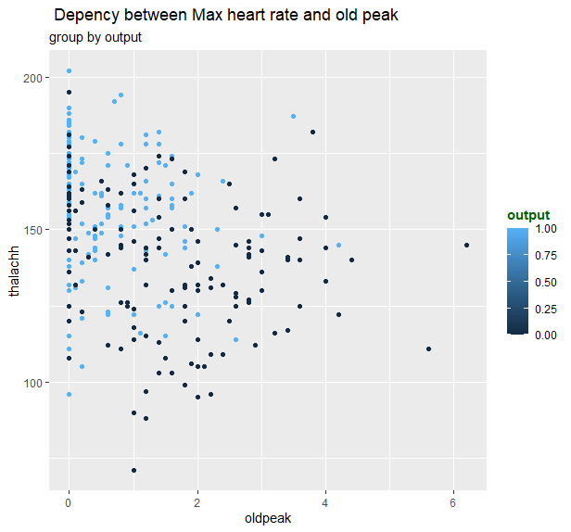
6. This graph shows the distribution of max heart rate by age. Shades of blue colors indicate the stress level. It is clear from this graph that max heart rate decreases slightly with age. Furthermore, it can be seen that the stress levels of the patients here are quite high. 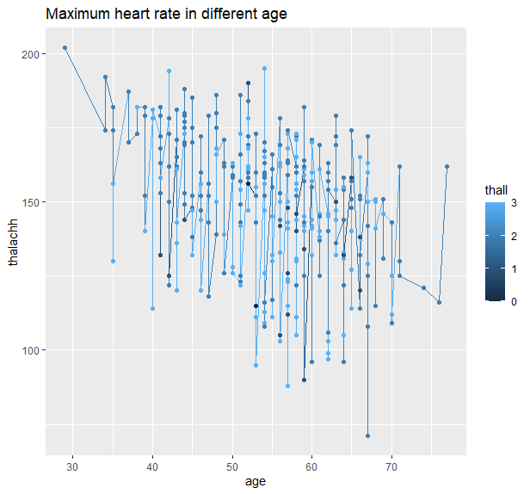
7. Blood pressure density. The result of blood pressure is mostly between 120 and 150. Other important parameters are minimum blood pressure of 90 and a maximum of 200+.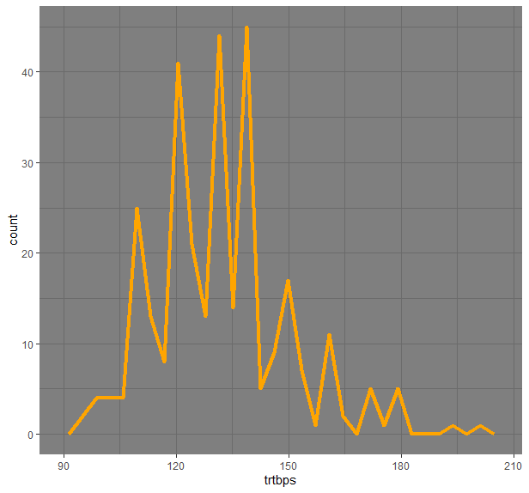
8. We have 5 types of major vessels. We can show major vessels count significantly decrease. 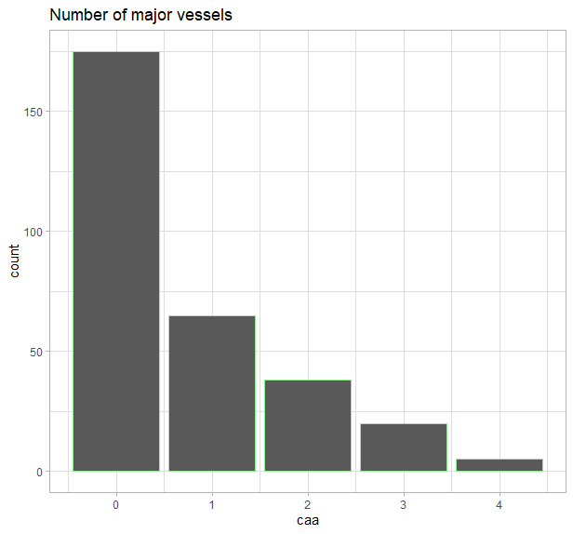
9. Dependency between blood pressure and heart rate factor by angina. As we know we have 2 types - those who have angina and who do have not angina. Those with angina have a slightly higher max pulse than those without. 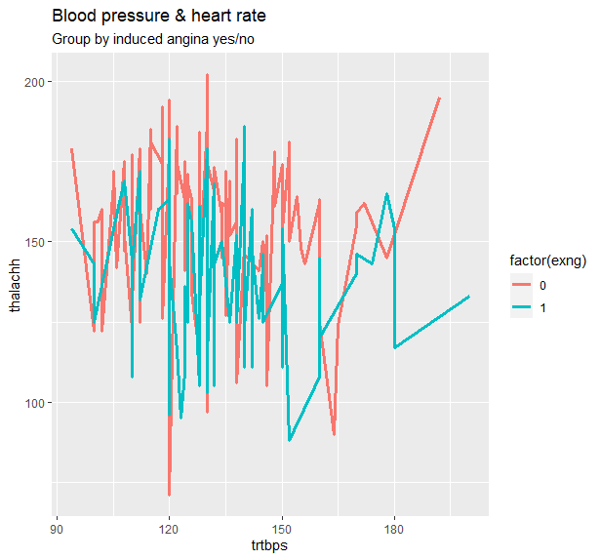
10. In the last graph, I divided the chest paint type into 4 parts with facet_wrap and showed it in a separate graph. I have determined the level of cholesterol according to the age and gender of the patients. In general, although the number of men is less than the number of women, the most cholesterol is in men and the least in women. Another important symptom is the 4th type chest pain, which occurs only in women. 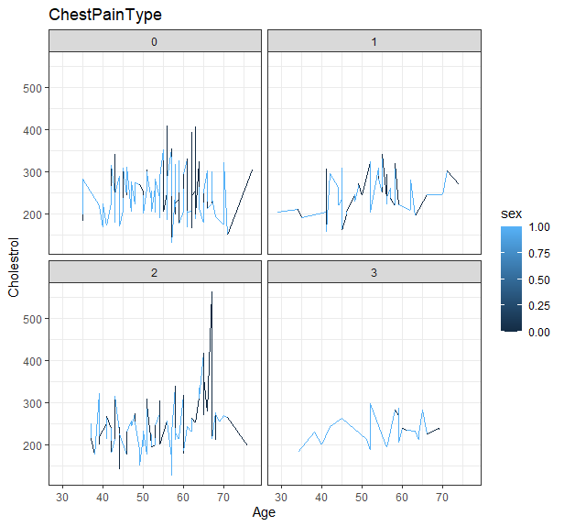

**House Data**

This data was taken from Azerbaijan building sales sites. We can see the price of the house, rent price, size of the house, room counts, the house located on which floor and the sum of floors of buildings.

Furthermore, I change some character variables to int. Condition of the house (very bad, bad, normal, good and very good), the area type of building located city center (yes or no). Finally, I separate houses due to the type of the item (empty house, a few items and full house).

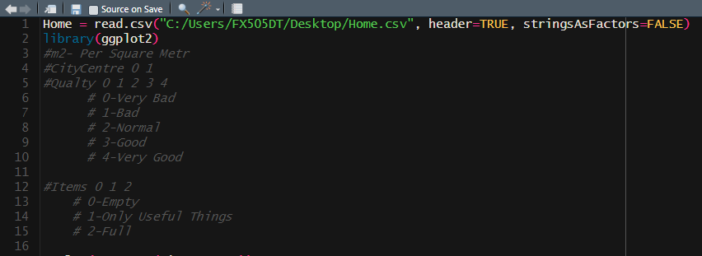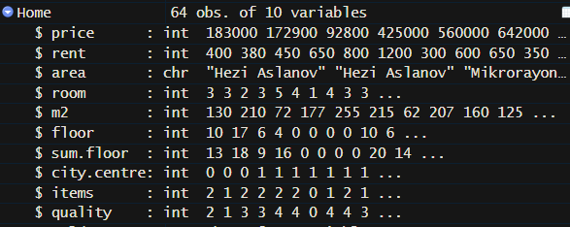

1. The Bar chart shows a number of buildings which are located city center and other ones not located in the city center. We observe that the number of houses in the city is twice as large as the number of houses that are not in the city. 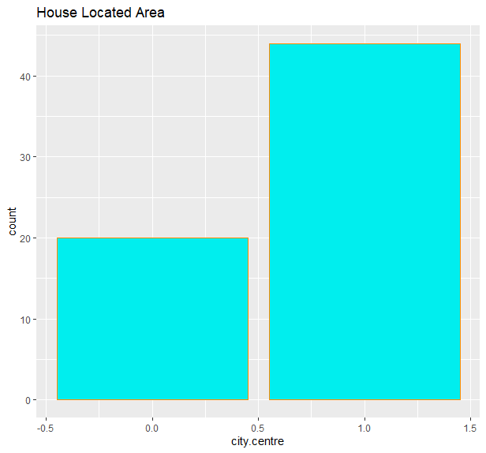
2. This graph shows the price difference according to the number of rooms. As shown in the figure, the price of the house increases as the number of rooms increases. I have added the graph 'smooth' to make it clearer. 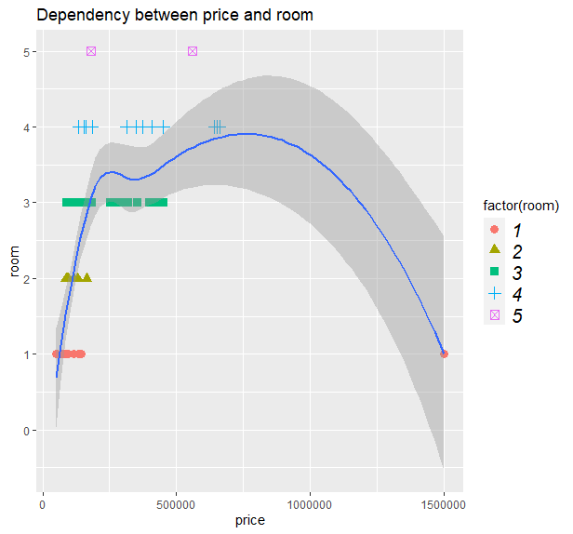This line graph shows the change in rent prices depending on whether it is located in the city center or not. This graph shows that the price of houses located in the city center is more expensive than the price of houses not located in the city center.
3. The 4th graph shows the dependency between sum of floor and house of floor according to the items' size and shape. 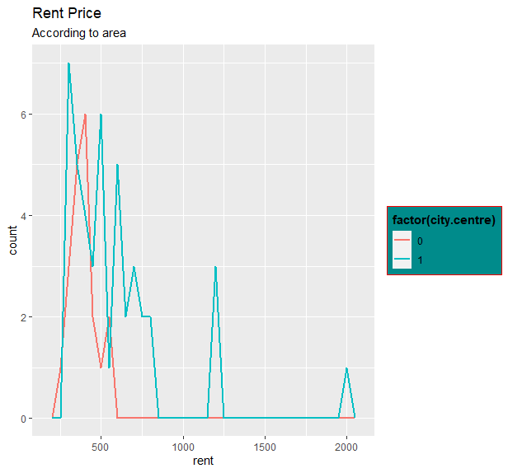
4. This graph illustrates the dependence on size and rental price for each quality (very bad, bad, normal, good, very good) separately with facet_grid. 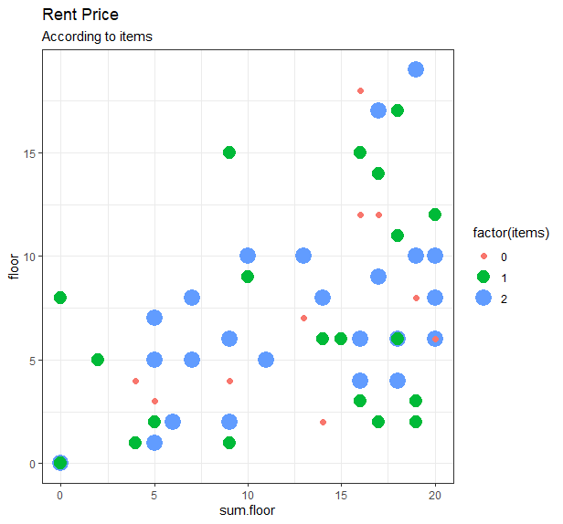
5. In this graph, I have shown the condition of items separately according to each region. 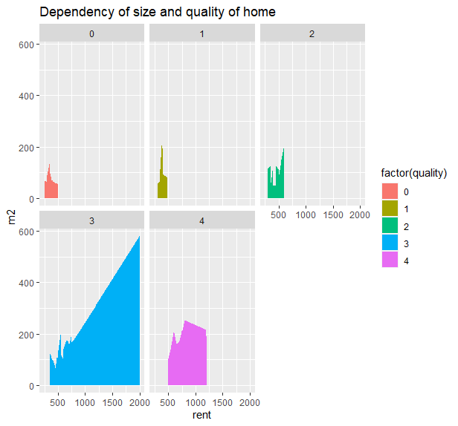
6. The final graph shows the height of the house and its quality dependency. It can be seen from the graph that the quality is better in buildings with higher. However, there is an exception here, the houses with "very good" quality are the lowest. The reason for this is the delegation's houses and villas. Their height is pointed as less in the database. I created this graph with facet_grid but it is not very clear on facet_grid which is why I also add a normal version of the graphic. We can see both types of graphics. 